Sunny Shah

ECEP 480 Solar Energy Engineering

Assignment 2: Electric Vehicle Charging Equipment

To charge an electric vehicle one needs to use EVSE or Electric Vehicle Charging Equipment, which is used to manage electrical energy from an electricity source to the electric/plug-in vehicle or PEV. EVSE for plug-ins are separated into three categories, set by the rate at which the batteries are charged. Level 1 and Level 2 provide alternating current or AC electricity to the vehicle, with the vehicle’s onboard charger converting AC to the direct current or DC needed to charge the batteries. The third type of charging is DC fast charging, which provides DC electricity directly to the vehicle.

No matter the rate at which the EVSE is running at, the charging times vary by many factors. The type or level of EVSE; the type of battery, its energy capacity, and how depleted it is; and the size of the vehicle’s internal charger. EVs generally have more battery capacity than PHEVs, so charging a fully depleted EV takes longer than charging a fully depleted PHEV.

Level 1

Level 1 provides charging through a 120V AC plug and requires electrical installation per the National Electrical Code. Most, if not all, PEVs will come with a Level 1 EVSE cord set so that no additional charging equipment is required. Shown in Figure one the connector, on one end of the cord is a standard three-prong household plug and on the other end will have a standard J1772 connector. The J1772 connector is the interface that the car will connect to. This level is typically used in residential locations. Adding only 2 to 5 miles per charging hour depending on the vehicle battery technology. As Table 1 shows the typical charging time from battery depletion to full is about 20 hours. Figure 2 shows the connection from the wall to the cars battery, which is similar in both level 1 and level 2 but in AC input for level 1 is at 120V AC.

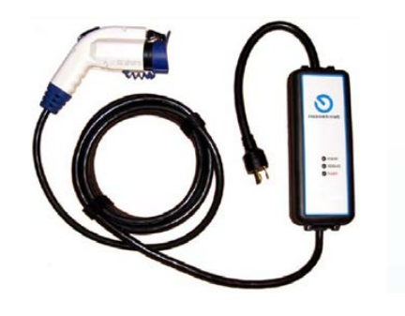

Figure 1. J1772 Connector to 120AC [3]

Level 2

Level 2 EVSE offers charging through a 240V AC, and is the most popular because it can easily charge a typical EV battery overnight, and it is most commonly found the home, workplace, fleet, and public facilities. Unlike the Level 1 this level takes some installation, the installation of charging equipment and a dedicated circuit of 20 to 80 amps depending on the EVSE requirements. Again Figure 3 shows the connection from the AC supply to the vehicle for a Level 2 system. Based on the battery type, charger configuration, and circuit capacity, Level 2 charging adds about 10 to 20 miles of range to a PEV per hour of charging time. Also, Table 1 shows that from a complete depleted battery charging time is about 7 hours.

J1772 Connector

Level 1 and Level 2 EVSE both use the same type of connector and the pin layout can be seen in Figure 5. On the connector side, we have pins 1 and 2 to manage the AC phase, pin three is ground, and pin 4 is for the proximity sensor on the car.

DC Fast Charging

DC fact charging EVSE requires an even higher AC source of 480V AC which enables the EVSE to rapidly charge the vehicle. Depending on the vehicle, the DC fast charger can add 80 to 100 miles of range with 20 to 30 minutes of charging. This level also requires a special type of plug shown in Figure 2, which is a duel connection system with the standard J1772 connector. Figure 4, shows the DC fast charger and the difference between the two different systems.

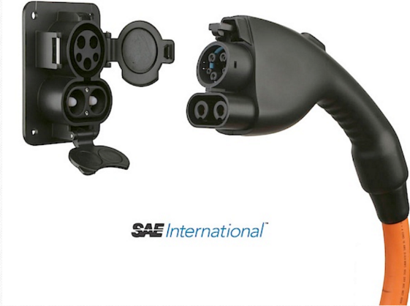

Figure 2. DC fast charging connector [4]

Table 1. EVSE General Characteristics [3]

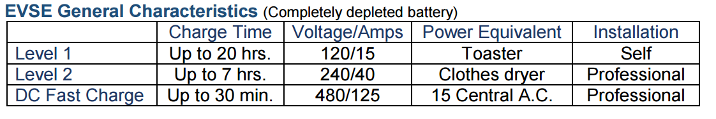

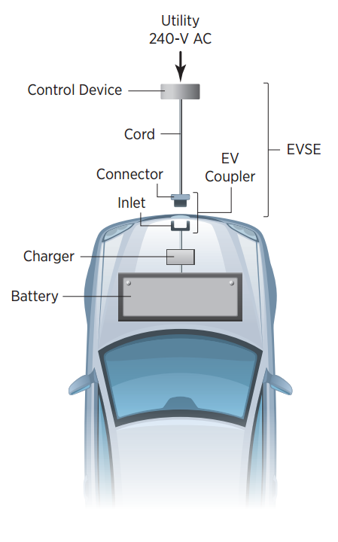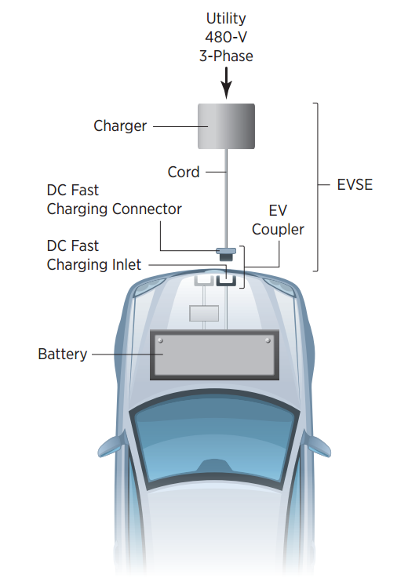

Figure 4. DC fast Charging Diagram [2]

Figure 3. Level 2 Charging Diagram [2]

Figure 3 and Figure 4 show the diagrams of how the electricity is charged to the cars battery in Level 1/2 and DC fast charging. As you can see the technology is very different, on the DC fast charging vehicle the battery is directly connected to the connector and there is an external charger that takes the 3 phase 480V AC voltage into a DC voltage to supply the car. While in Figure 3 we have the charger with in the vehicle between the connector and the battery. So this and the different battery technologies all very and limit the charging rate from vehicle to vehicle.

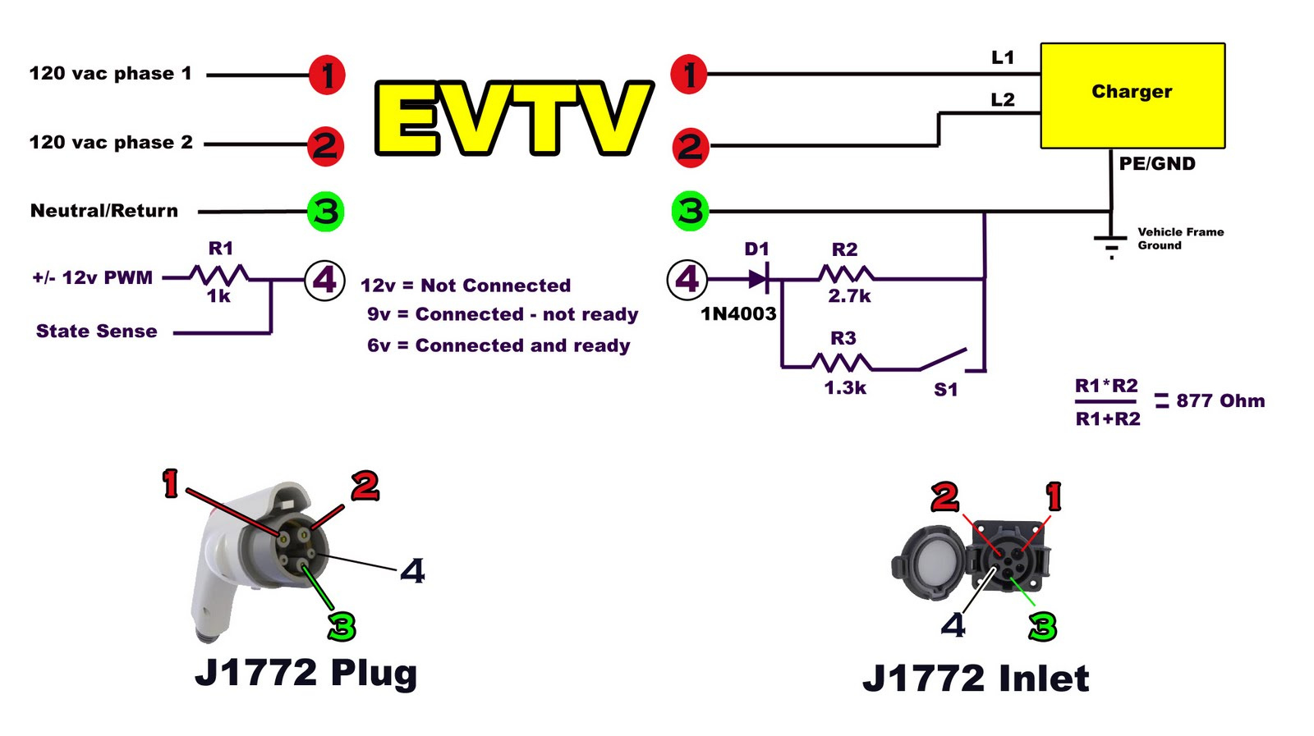

Figure 6. J1772 pin layout [1]

References

[1] J. Rickard, "J1772-2009 charging for your EV - EVTV motor Verks," in Batteries, EVTV Motor Verks, 2011. [Online]. Available: http://evtv.me/2011/01/j1772-2009-charging-for-your-ev/. Accessed: Jan. 25, 2017.Ve

[2] "Plug-in Electric vehicle handbook," in *U.S Department of Energy*. [Online]. Available: http://www.afdc.energy.gov/pdfs/51227.pdf. Accessed: Jan. 25, 20

[3] "Electric vehicle Transportation Center," in Electric Vehicle Charging Technology Analysis And Standards. [Online]. Available: http://www.fsec.ucf.edu/en/publications/pdf/FSEC-CR-1996-15.pdf. Accessed: Jan. 25, 2017. 17.

[4] T. Marcucci, "How the J1772 charging standard for plug-in vehicles works," EDN, 2013. [Online]. Available: http://www.edn.com/electronics-blogs/automotive-currents/4421241/How-the-J1772-charging-standard-for-plug-in-vehicles-works. Accessed: Jan. 25, 2017.